13th German-Japanese Bridge Symposium

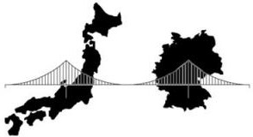

***GJBS***

Osaka, Japan, August 2023

ABSRACT TITLE

**Presenting Author**\*1**, Second Author**1,2**, Third Author**2 1Department name, Institution 1

2Department name, Instituion 2

*contact: [correspondingauthor@email.com](mailto:correspondingauthor@email.com)

Enter your abstract here. Ensure that your document is no longer than 1 page in length. Authors are invited to submit electronic abstracts (maximum of 300 words) before March 20, 2023. Abstracts must show the full title of the paper, names and affiliations of all authors, and the full mailing address of the lead authors. Abstracts will be reviewed and lead authors notified of paper acceptance in April 20 2023. After acceptance of an abstract authors can decide about standard or blind full review of full paper. We recommend adding an eye-catching figure as shown in Figure 1. Just make sure that the total length of the abstract is no more than 1 page.

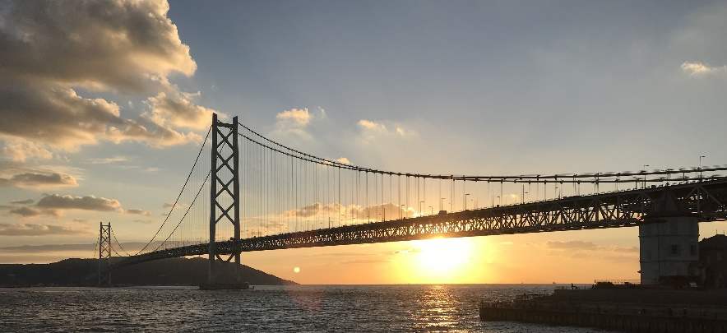

Figure 1: Sample figure

Any references should appear together at the end of the abstract, listed alphabetically by last name of the first author. Cite in the text using commands (bridge Alpha, 1984; Bridge Beta, 1983) or Lab (2023).

**References**

bridge Alpha (1984). This is the template reference. Journal of Abc Ddef 1(2), 3–4

Bridge Beta B. G. (1983). This article title. Journal of bridge xxxx 4(5), 74–76.

Lab B. E. (2023). Akashi kaikyou bridge.